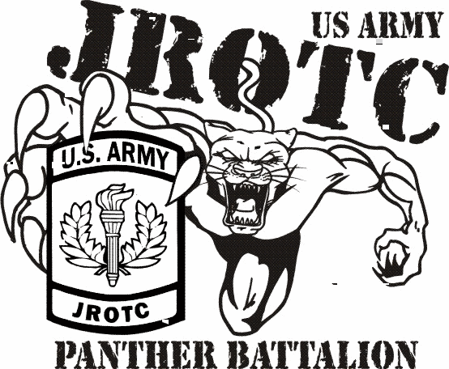

What is JROTC
The Junior Reserve Officers’ Training Corps (JROTC) was organized by the National Defense Act of 1916 and Pell City HS JROTC was established in 2005. The focus of the program is citizenship and leadership development. You will earn either PE, Elective, or Career Tech credit and receive a Career Tech endorsement on your diploma after 3 years. The instructional staff is comprised of Major Kelly Savage and Sergeant First Class Richard Agnew.

Requirements for JROTC
- Registered in the 9th – 12th grade
- Physically fit to participate in JROTC
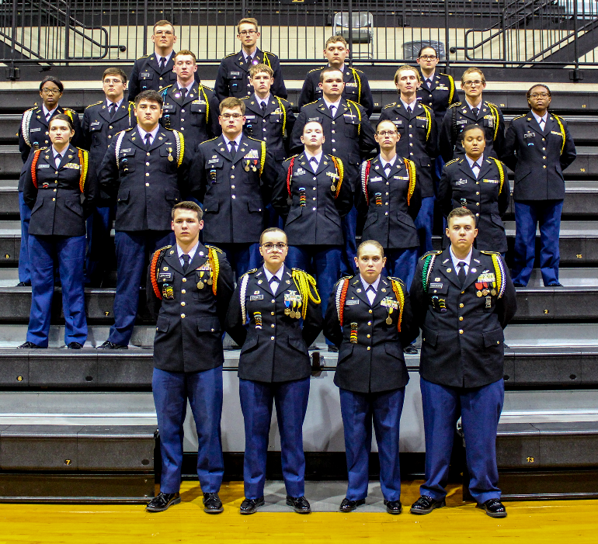
- Qualified morally and academically

JROTC at a Glance
- No military obligation, however, cadets may qualify for accelerated promotion in the active or reserve forces. Possible advanced placement for college ROTC
- A self-development program in a military framework and leadership development
- Classroom instruction, leadership lab, guest speakers, current events, physical training, and extracurricular activities
- Assistance in applying for college ROTC scholarships and service academy appointments
- Activities: Military Ball, Field Trips, Community Service, Awards/Promotion Ceremonies, & Drill Meets

Join Winning Teams
Academic, Color Guard, Drill, Exhibition, Rifle, Orienteering, security, and PT Teams

For Additional Information
Mail: Pell City High School JROTC
1300 Cogswell Ave
Pell City, AL 35125

Phone: (205) 338-4497
Email: savagekpchs@yahoo.ocm
or agnewrpchs@yahoo.com

