Panther Battalion
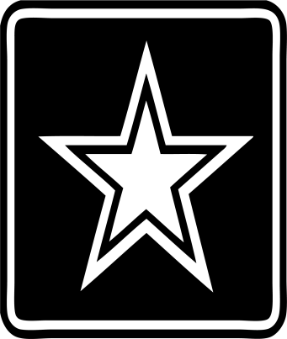
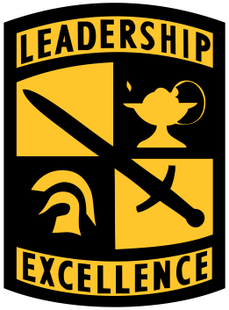
News

Upcoming Events
September 1: 7:40 a.m. JROTC Club
September 16: Orienteering Meet
September 23: Homecoming
September 24: Sparkman Drill Meet
October 8: Stanhope Drill Meet
October 14: ASVAB
October 19-21: Fall Break
October 29: Orienteering Competition
November 5: PCHS Drill Meet
November 11: Veterans Day
November 21-25: Thanksgiving Holiday
December 1: Promotion Ceremony
December 10: Military Ball
December 19- January 2: Christmas Holiday

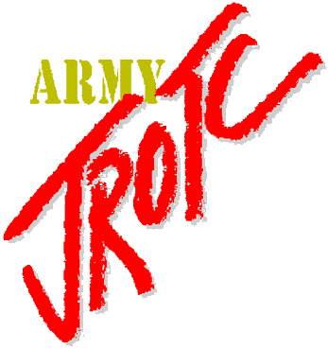
JROTC
The Sparkman Drill Meet was a success! At this competition, cadets were judged on unarmed and armed inspections, platoon exhibition, platoon regulation, color guard, and physical fitness. Cadet Second Lieutenant Bradley Turner, Drill Team commander, lead his team to five first place awards, two second place individual awards, and three third place awards. Cadet Major Alaina Payne, Color Guard commander, helped her teams to one first place award and two second place awards. Cadet First Lieutenant Jesse Frank, Physical Fitness commander, guided his team to a first place award. Pell City High School JROTC received first place overall for Area 1.
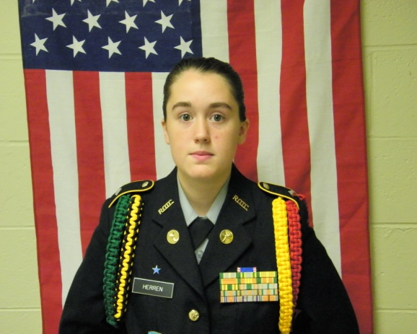
Get to Know Your Staff
Our XO is Cadet Major Herren. Major Herren is a senior cadet this year with big dreams. She plans on attending UAB to study nursing. She wants a career of helping people. Although planning for college is ideal, we must reflect on what JROTC has taught us. For Major Herren, JROTC has taught her how to have confidence in her ability to be a better person and leader.

